

PROPOSAL DOCUMENT

Microsoft 365 iOS Setup

© Sautech (Pty) Ltd. http://www.sautech.net

INTRODUCTION

The purpose of this document is to provide a complete step-by-step installation manual to configure your online hosted exchange profile. After all procedures in this document is followed completely, you will be able to connect to your new 365 mailbox using IOS mail.

setup
- Go to “Settings” then “Mail”.
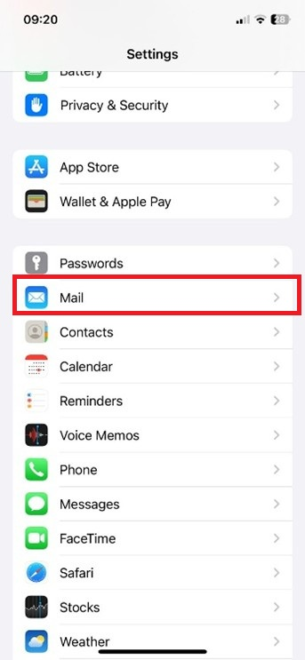

- Go to “Accounts” then “Add”
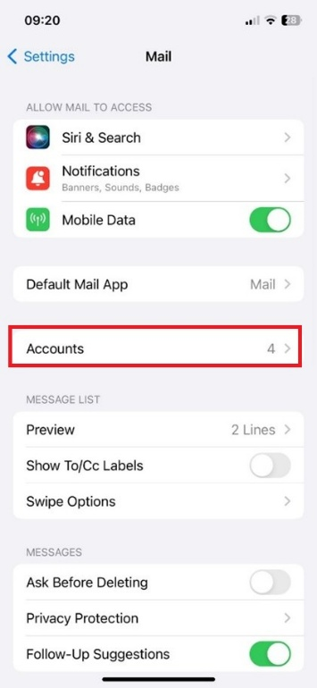
- Coose Microsoft Exchange
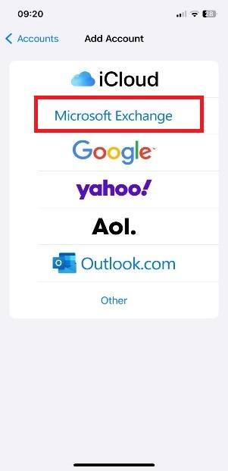

- Next
- Enter Email and Description
- Enter Username and Password
- Next Next

